Programming:

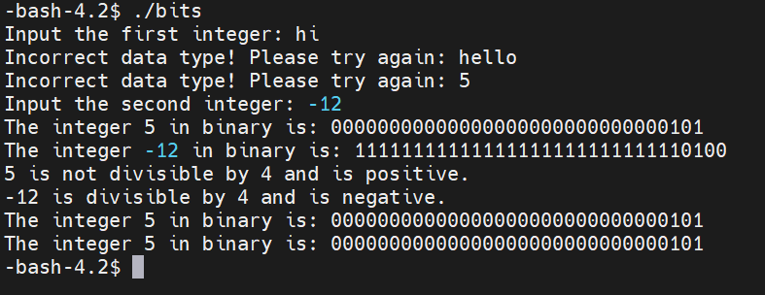

The program successfully send an error message when the user inputs anything that is not int and prompts another input. It also successfully converts the integer into binary format in two’s complement. It also checks if the number is divisible by 4 and if it is positive (or negative) by checking the specific bit. It also manipulates the last bit of the first number to a 1 and print the new number in its binary format.

Short Answers

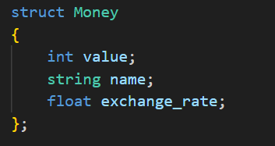

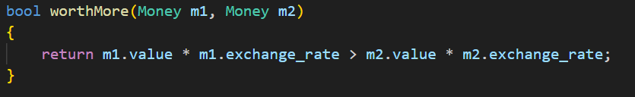

1. $4*2*10=80$. The size of one int is 4 bytes. Point object has 2 int which makes it 8 bytes. And the array has 10 Points which makes 80.
2. The function created the Point struct on the stack instead of the heap. Therefore, the program can’t access the data stored in result even if we passed the address out. To fix this problem, we can either return the object value out:

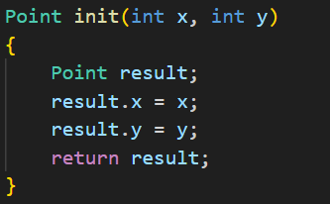

Or create the pointer struct on the Heap to the pointer outside the function:

1. The new/delete calls the constructor and destructor when dynamically allocating memory for the object. However, malloc/free doesn’t do that which can cause errors and even memory leaks.
2. Link list does not need to change the size which requires copying and pasting the old data to a bigger array. This process takes time and memory and link list completely negate that. However, it is harder to access the stored data in a link list because the objects are all located separately in the memory which requires the program to go through each linked item to get to the specified index.

